**School of Computer Science**

**UNIVERSITY OF PETROLEUM AND ENERGY STUDIES**

**DEHRADUN, UTTARAKHAND**



**System Provisioning And Configuration**

**Management**

**Lab File**

**(2024-2025)**

**for**

**6th Semester**

Submitted To:  Submitted By:

Dr. Hitesh Kumar Sharma Parth Paul

B. Tech. CSE DevOps

- [6h Semester]

Parth Paul

**Experiment 11 – Configure Ansible Setup In Linux:**

Steps:

1. Create two Amazon Linux t2.micro instance - Ansible Server & Node

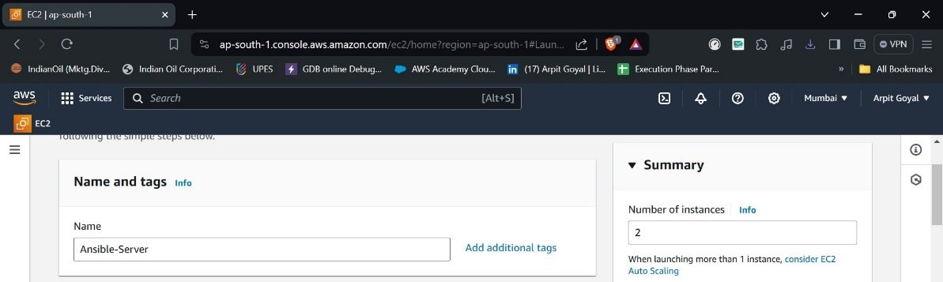

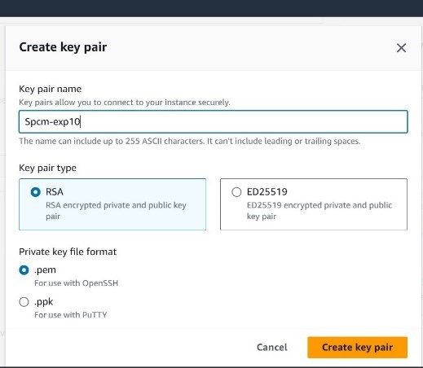

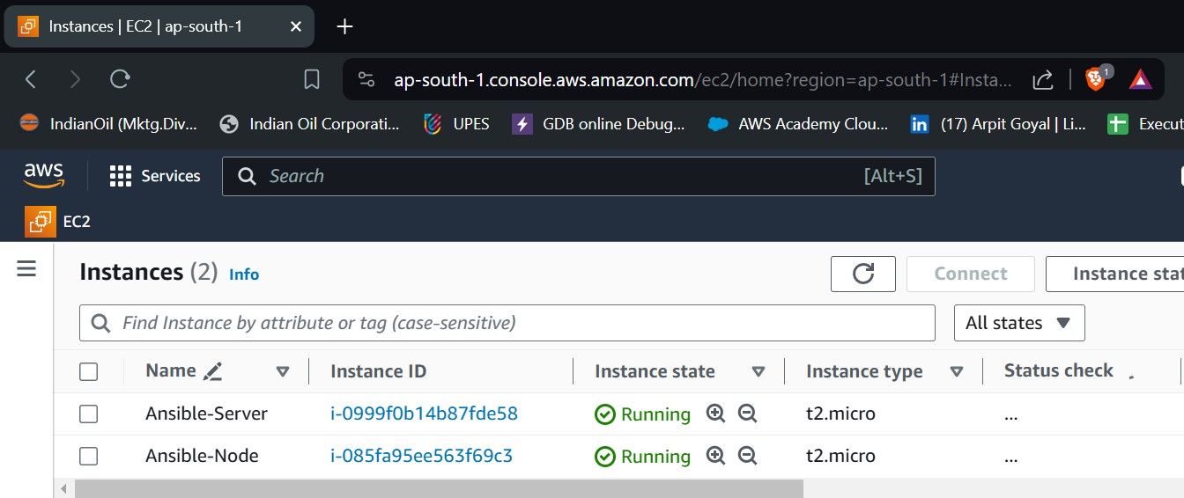

1. Install ansible on Ansible Server

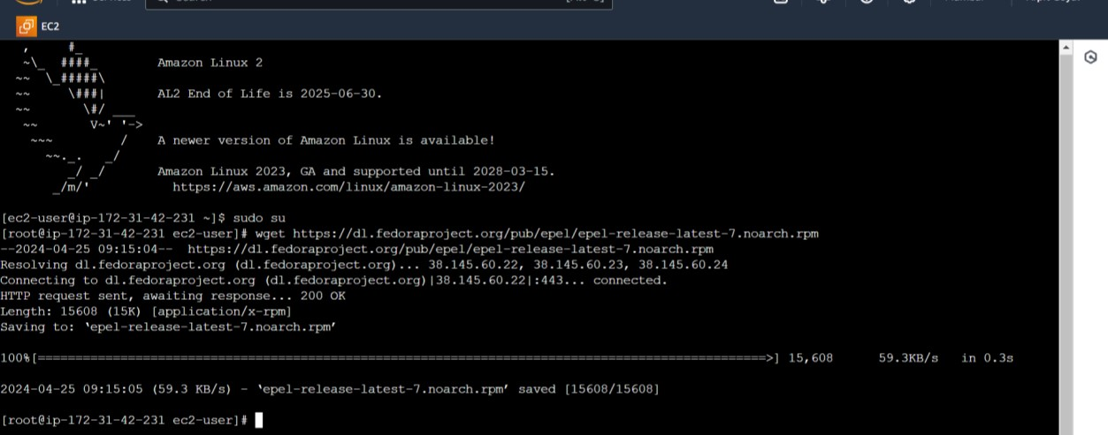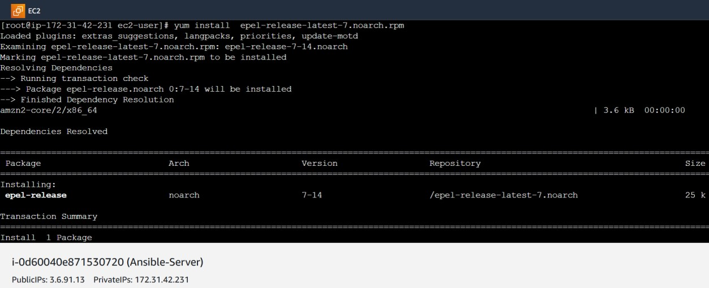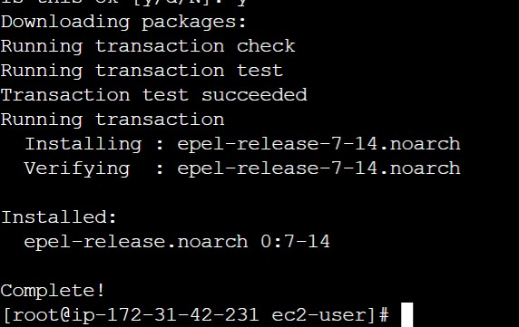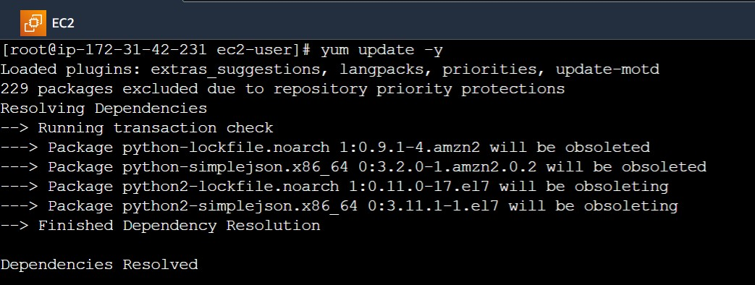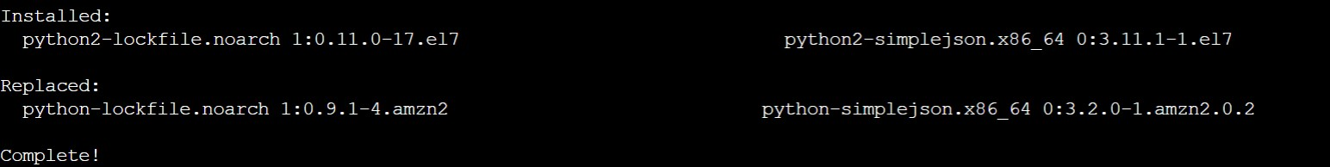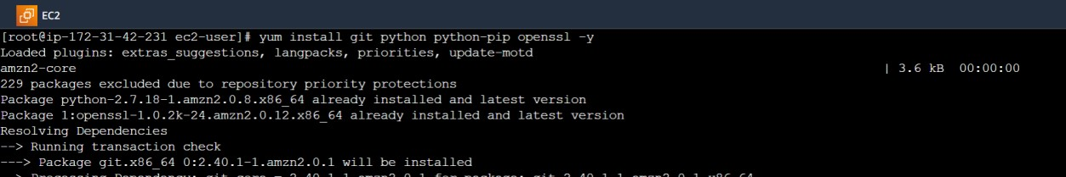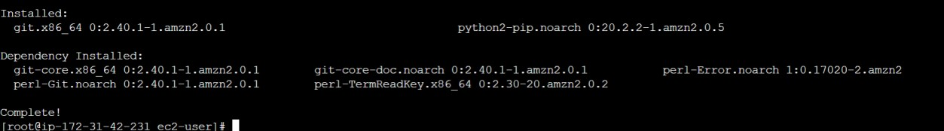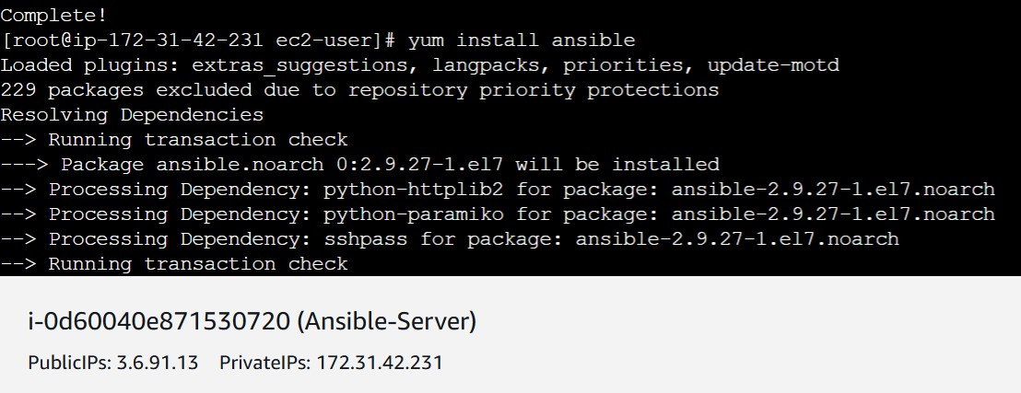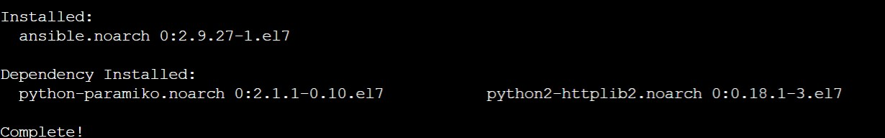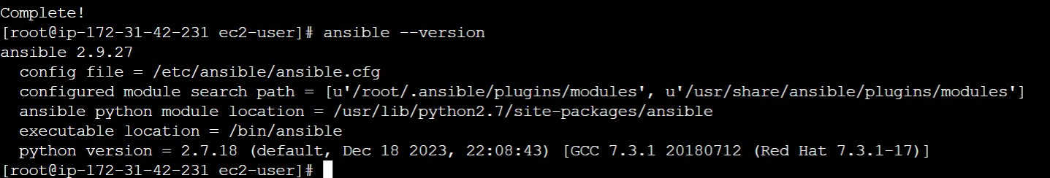

3.Connect Node to Ansible Server and Add Private IP of node to the Ansible server’s inventory file

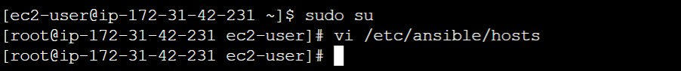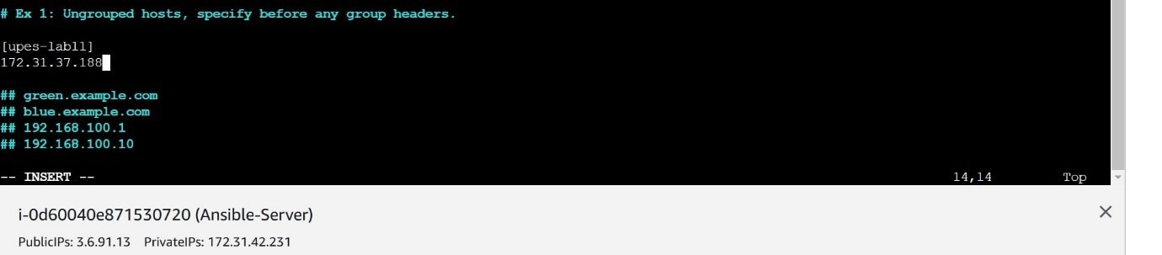

1. Create super user in both the machines

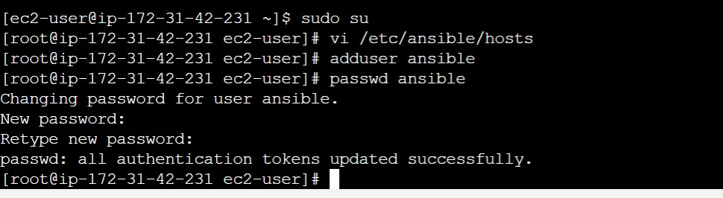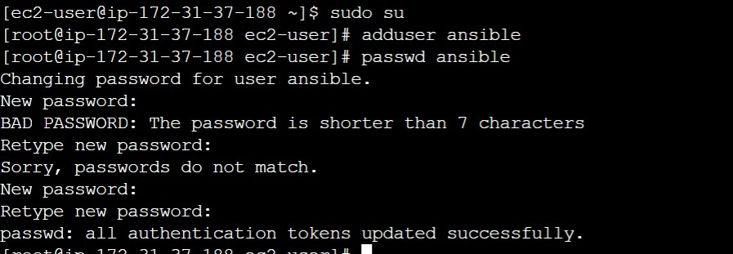

1. Give sudo user permissions to both users

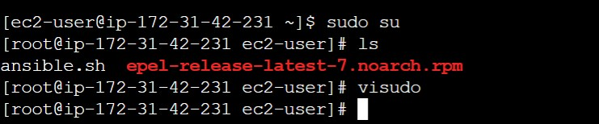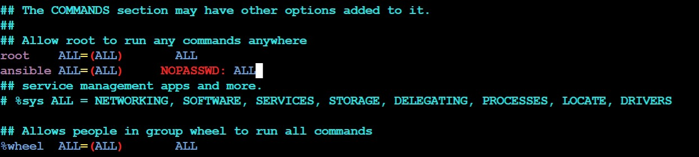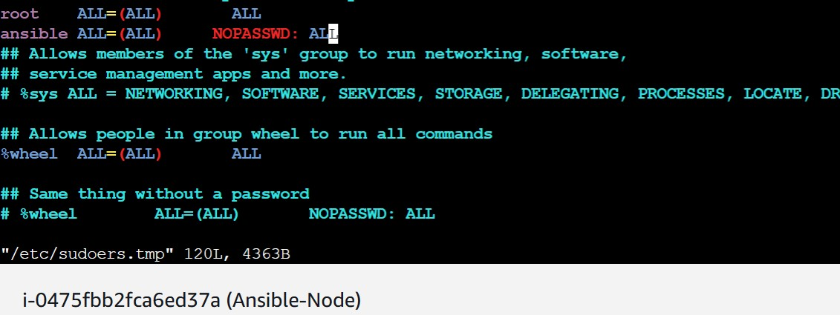

1. Edit the sshd_config file in the node server

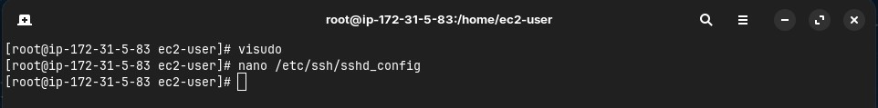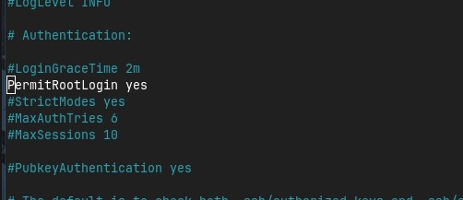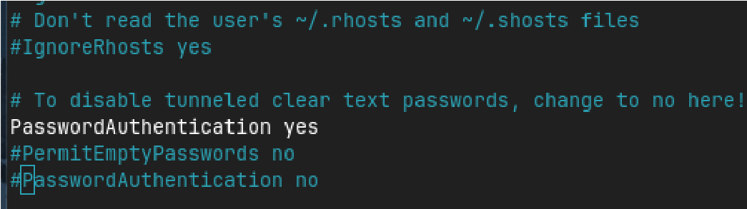

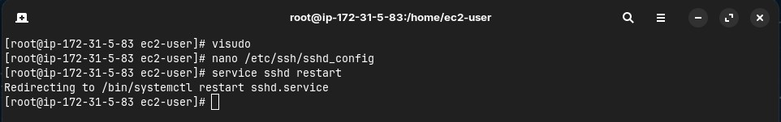

1. Generate key pair in Ansible server and copy the key to node server

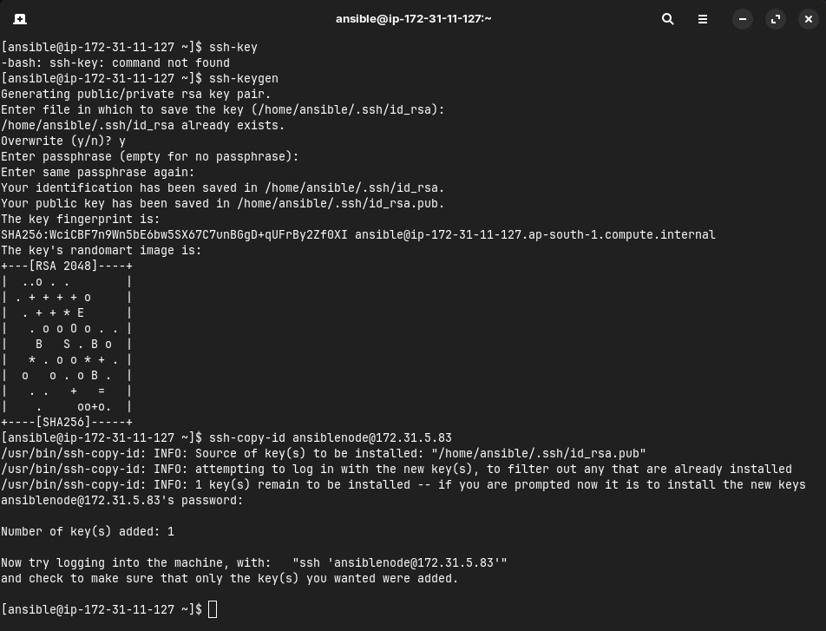

1. Connect to node server from ansible server

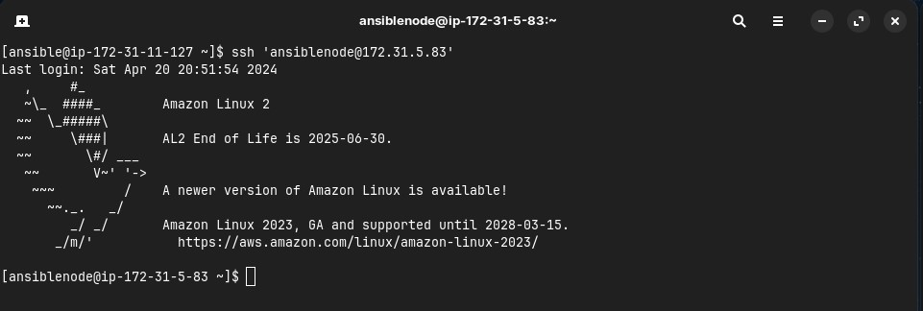

**Experiment 12 – Create and Run Ansible Playbooks:**

Steps

1. Repeat the steps in Experiment 11 to create the initial setup 2. Test adhoc commands

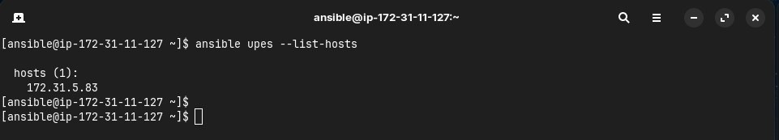

1. Install Apache server on node server using adhoc command

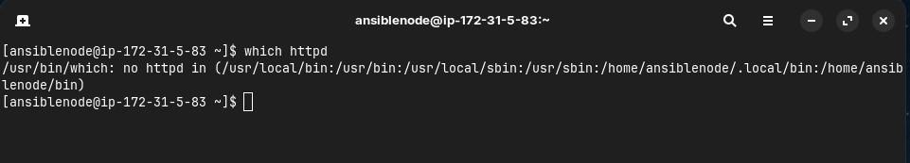

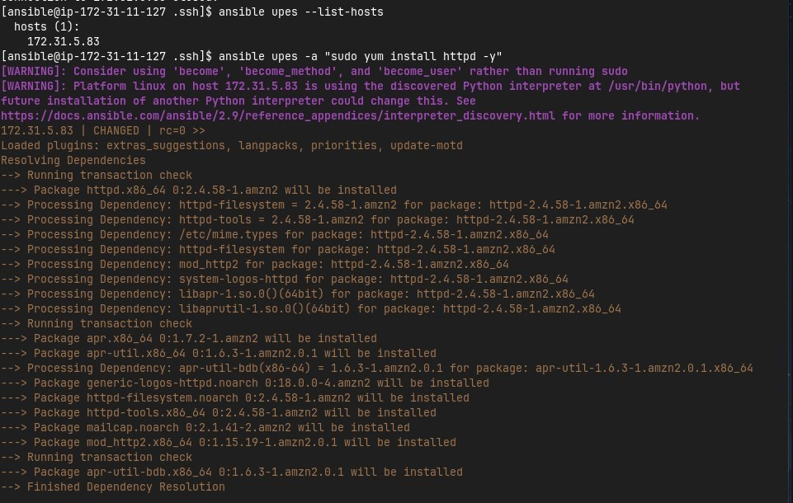

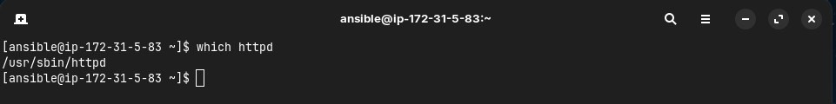

1. Start the httpd service using ansible

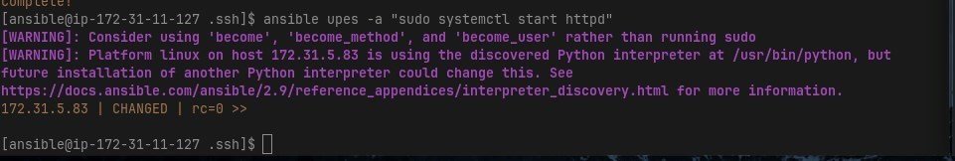

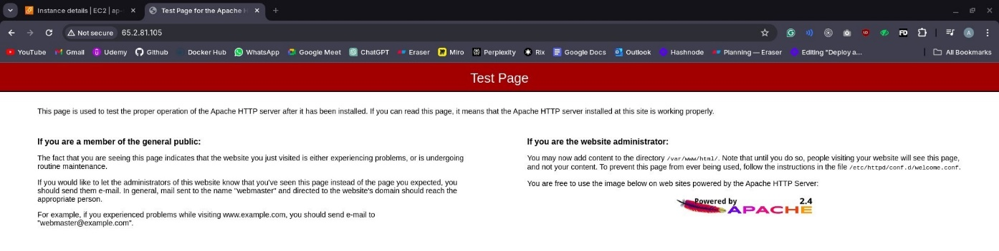

1. Remove ansbile and then reinstall using ansible playbook

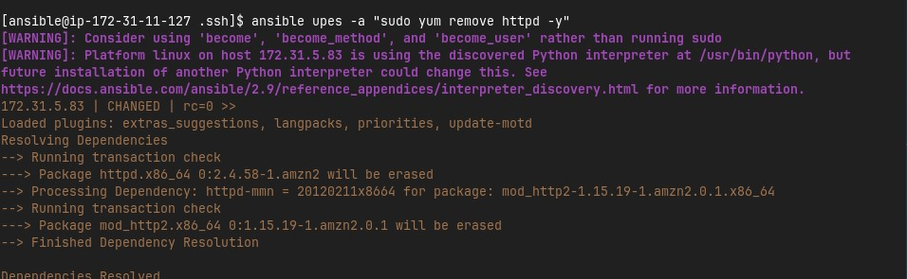

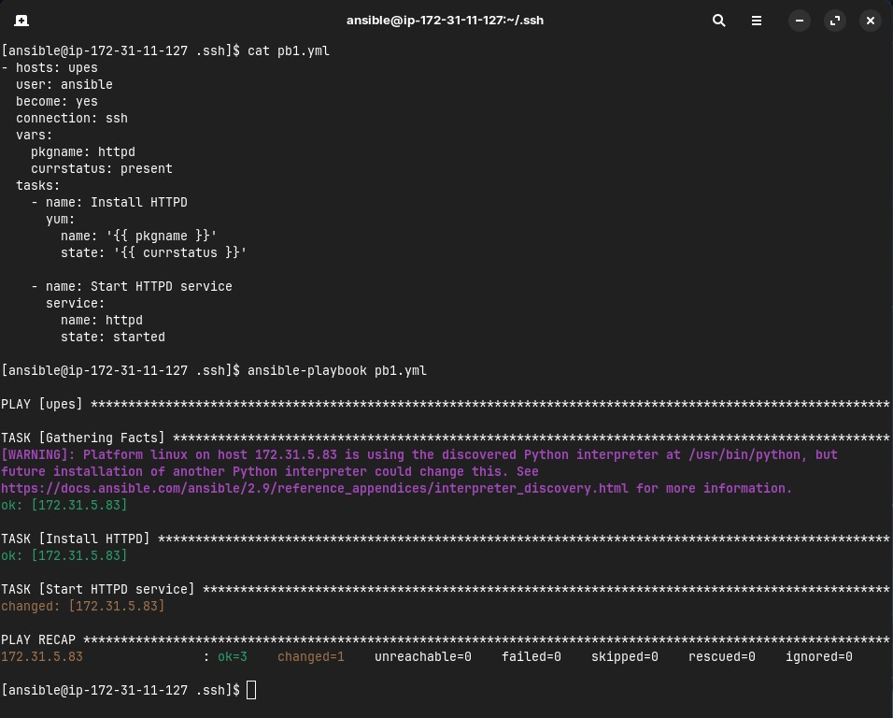



1. Testing other playbooks